User manual of Wordpress website

[www.chaletsandcaviar.com](http://www.chaletsandcaviar.com)

This manual was created to facilitate use and maintenance of website created on Wordpress platform by Christopher Nowak according to project nr 2/2017 approved 31st, July 2017.

List of topics

Introduction to Wordpress maintenance 2

Logging in and out 3

Creating an offer 4

a. Uploading and deleting photos 5

b. Creating, editing and deleting a gallery 6

b. Creating, editing and deleting an offer 7

Learning and sources 9

# Introduction to Wordpress maintenance

Wordpress is an advanced internet platform called CMS (Content Management System). Webpage *www.chaletsandcaviar.com* was build using Wordpress and modified theme Sirius Lite.

To manage basic information on website no professional knowledge is required. To add, modify or erase information on site user needs internet connection and one of common browsers such as Chrome, FirefoX, Safari, Internet Explorer, Edge or Opera.

Wordpress serves easy to learn and use administration interface. All information are organized in

* **pages** – constant rarely changed information like Contact or About us pages
* **media** – all **image** and video files *(important)*
* **sliders** – animated **galleries** of images usually placed at the end of an offer *(important)*
* **posts** – often updated information like **offers** *(important)*

On administration panel there are:

1. Main **Menu** on left side
2. **Handy Menu** on top – with logging out feature, quick creating or editing posts
3. **Working area** or **Dashboard** withsome useful information

**2**

**3**

**1**

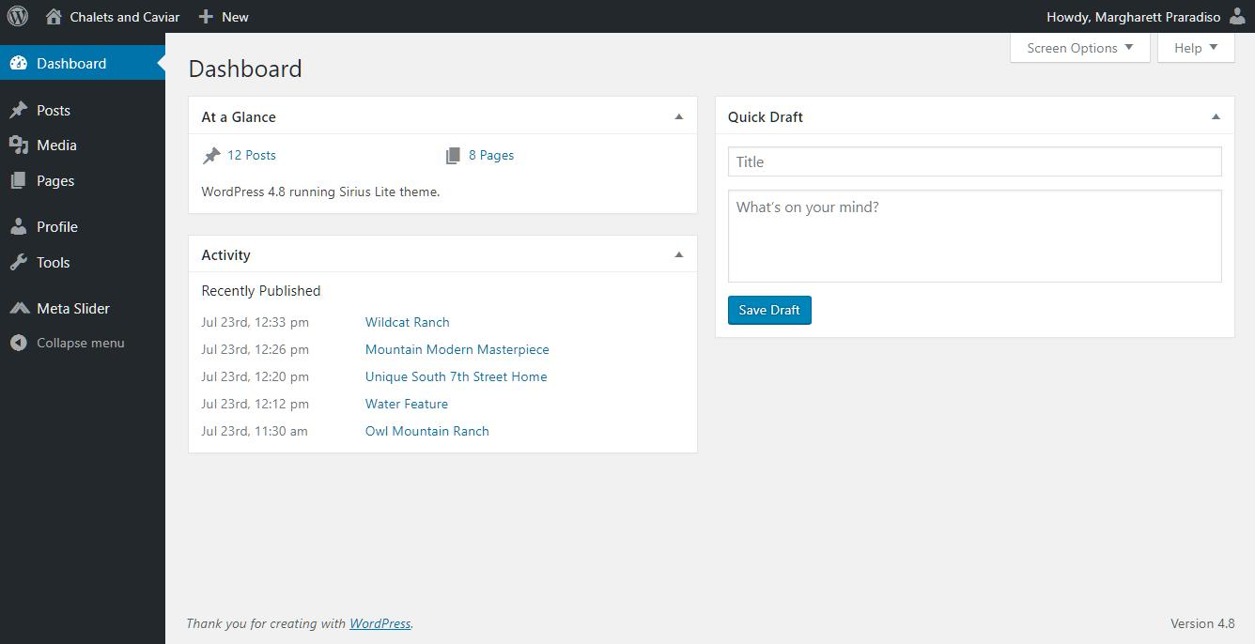

# Logging in and out

Administration panel is accessible at following address:

[www.chaletsandcaviar.com/wp-login.php](http://www.chaletsandcaviar.com/wp-login.php).

1. To enter administration area paste or type it in into your browser address box.

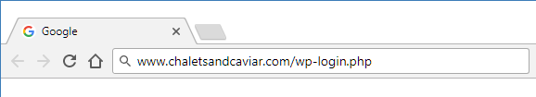

**1**

1. It will open login page. Please, type in
   1. name
   2. password   
      that has been sent by email
   3. Click **“Log in”** button.
2. To recover your lost password click link **“Lost your password?”** under the logging panel. You will need your email address – probably something like *info@chaletsandcaviar.com*. Proceed according to displayed instruction.

**3**

**2c**

**2a**

**2b**

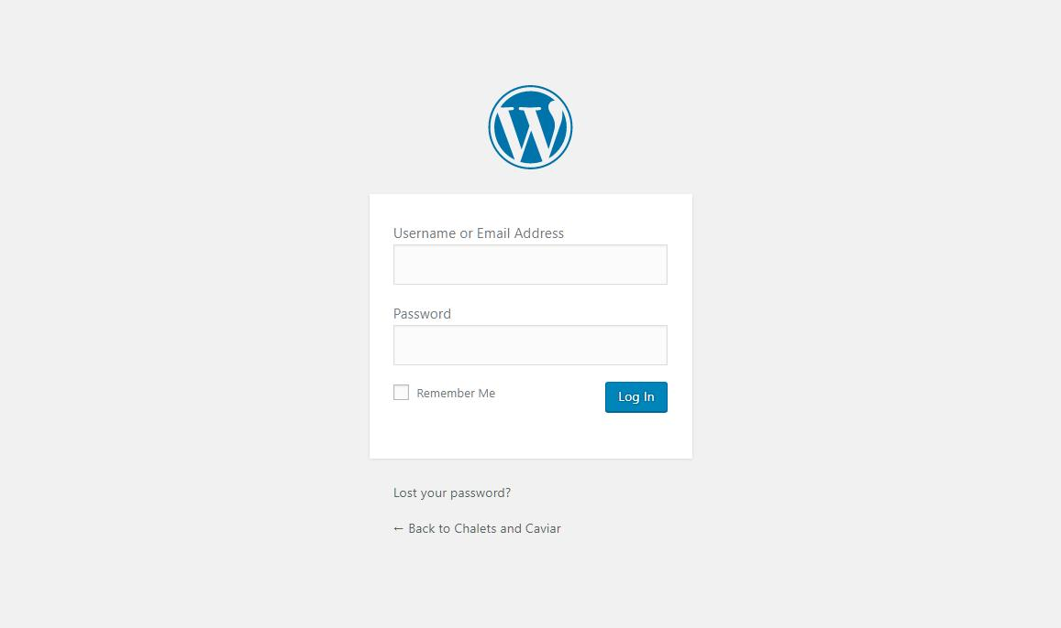

1. To end session and **“Log out”** use **Handy menu** in right top corner of administration panel.

# Creating an offer

To create an offer user needs to compose a **post** containing following elements:

* Title
* Content - Real estate description
* Featured image – leading photo of estate displayed on list of offers an in offer heading
* Gallery – bunch of animated self displaying photos of estate placed at the end of an offer

As user advance in using Wordpress he or she will find own way of working. For the beginning I suggest following this steps.

1. Upload photos
2. Create gallery
3. Create offer (post)

**Title**

**Content**

**Image**

**Galery**

**(slider)**

**Feutured**

**image**

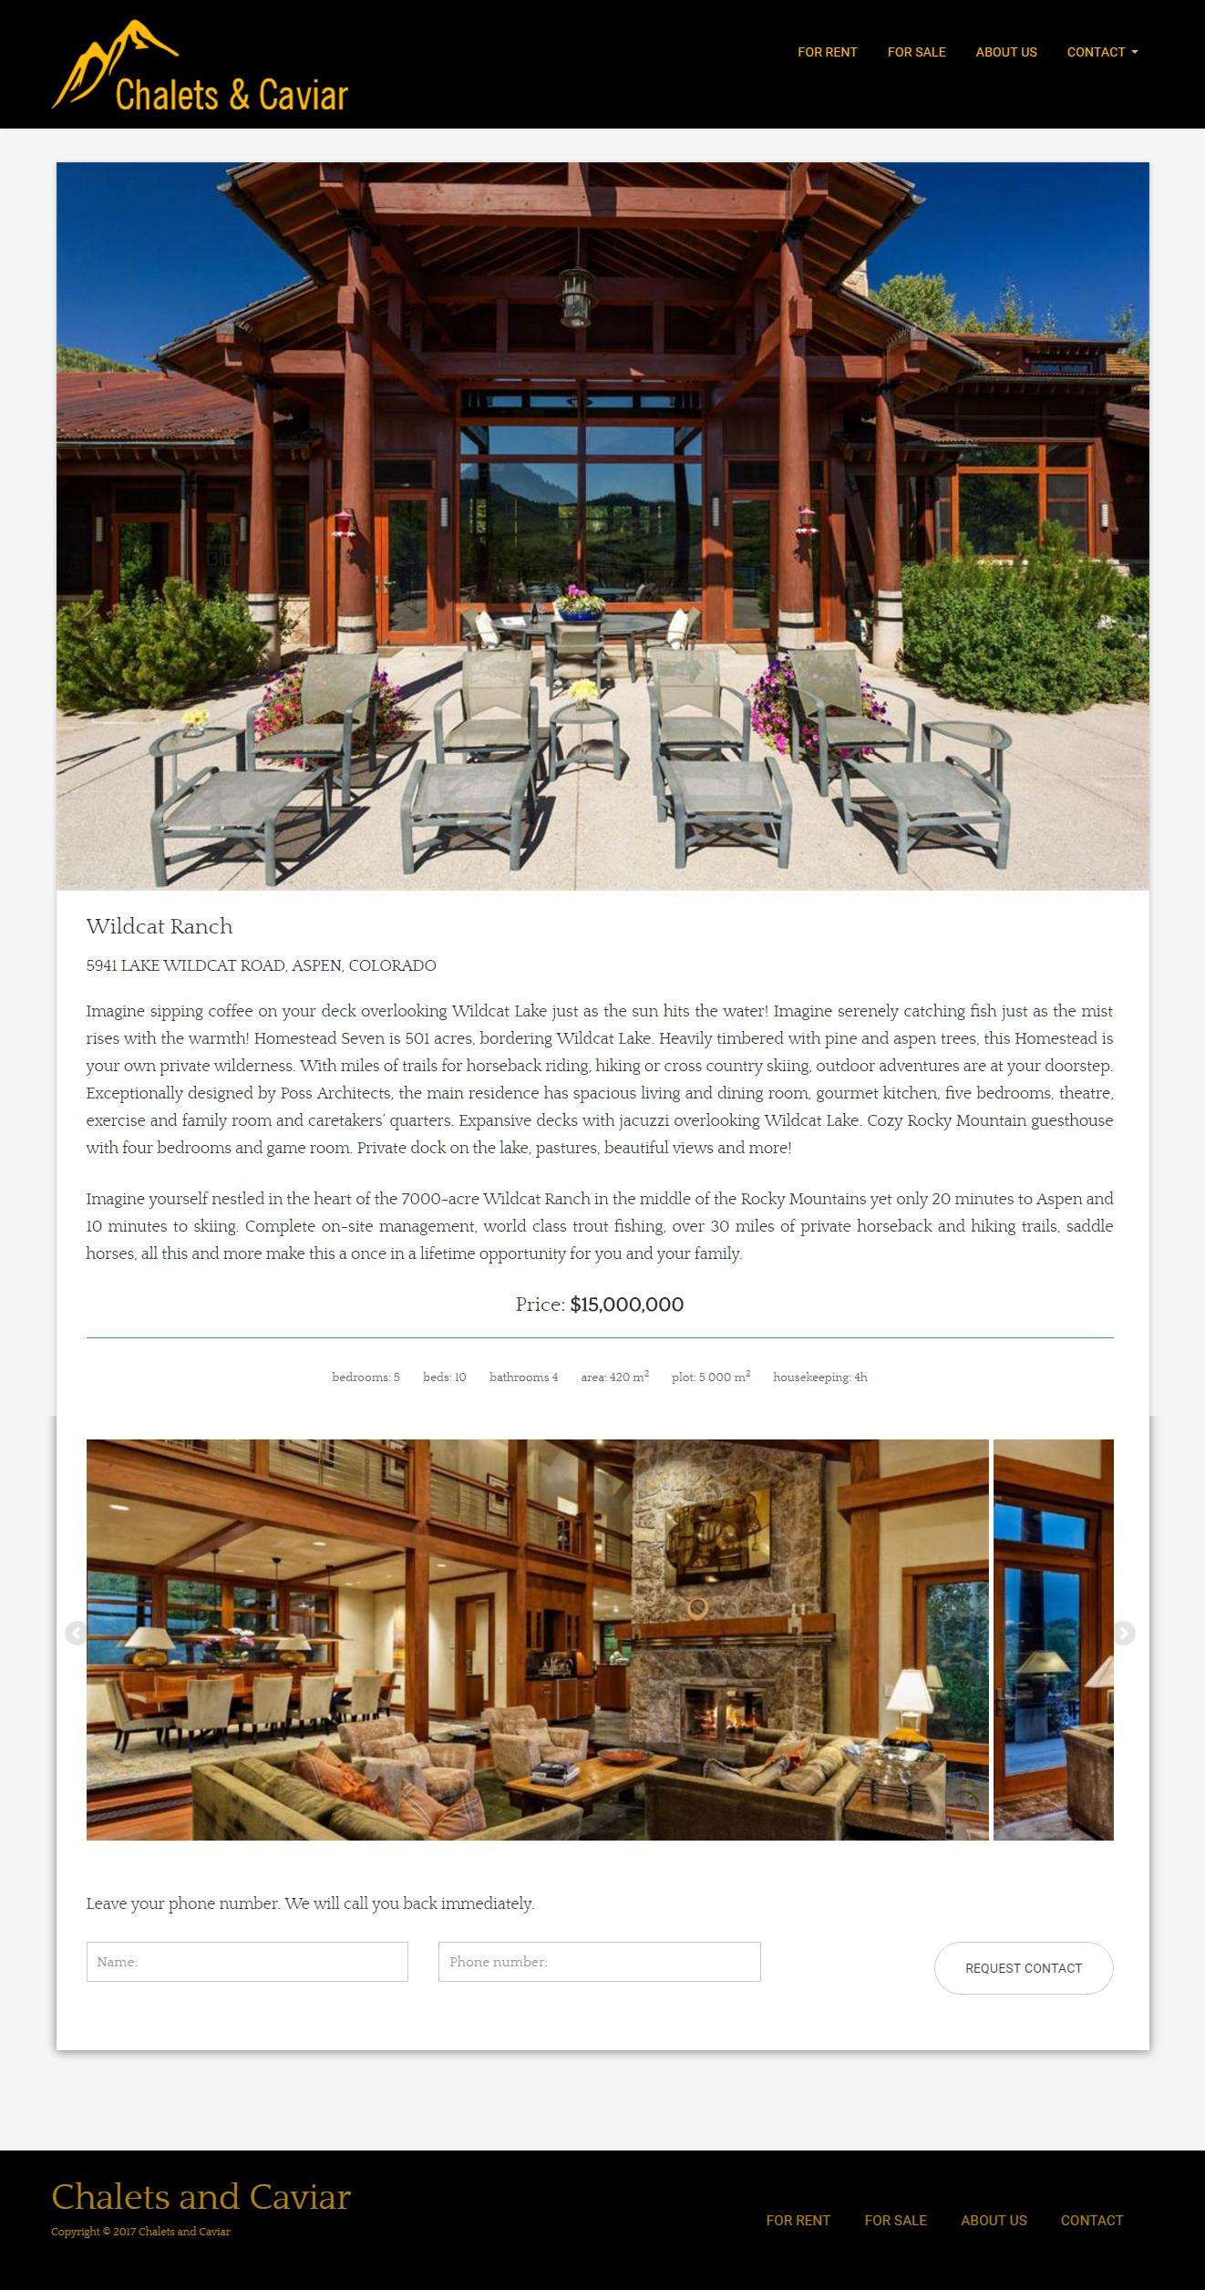

## Uploading and deleting photos

1. **Preparing collected photos of chosen real estate on your computer**
   1. Crop or resize collected images to **1024 x 680 px** size. It will look nice. Although Wordpress will manage other sizes of photos as well as portrait or landscape orientation.
   2. It is a good to **name your photos** the same as the name of your offer plus a number to let yourself easy browse through hundreds of images that you will collect in time.
   3. Store your photo compressed in **.jpg format** with 60-80% compression rate.
2. **Upload photos to Wordpress.** 
   1. Go to **“Media”** in menu on left side of the administration panel.
   2. Click **“Add New”** button
      1. Method I: Upload files conventionally using **“Select Files”** button and system window that will appear.
      2. Method II: Just select files and drag them from local folder to area described as **“Drop files anywhere to upload”** and surrounded with dashed line.
   3. Wait until progress bar disappears and you see thumbnail of your photo. Images have been added. You can add images one after one or collectively.
3. **Removing photo**
   1. Go to **“Media”** in menu on left side of the administration panel. Click image that you want to remove. On photo page click link **“Delete Permanently”**.

**Uploading photo**

**2**

**1**

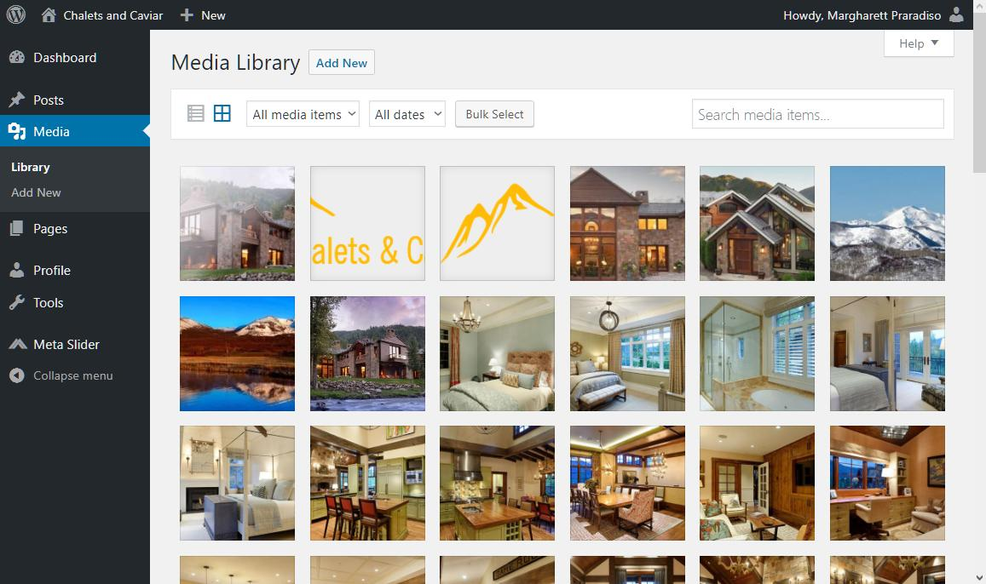

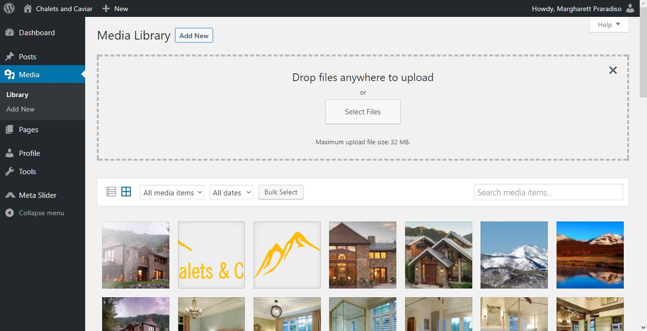

**2b**

**2a**

**Removing photo**

**4a**

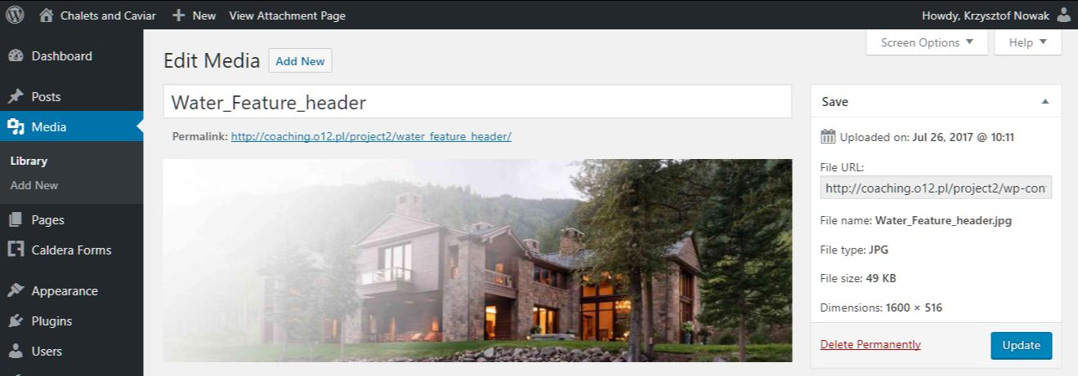

## Creating, editing and deleting a gallery

After uploading estate photos create a gallery that will be placed at the end of an offer.

1. Open **“Meta Slider”** item in menu on the left side of administration panel
2. Create new gallery.
   1. Click **“+”** tab.
   2. Click on **“New slider”** tab to set the name of newly created gallery. Keep the name the same as name of an offer you creating.
3. Add photos to gallery.
   1. Click **“Add Slide”** to add photos to gallery.
   2. In modal window click “**Media Library”** to use previously uploaded photos (you can use **“Upload Files”** to upload new ones).
   3. Click thumbnails to select, click again to deselect. Use **“Search field”** to easy find desired images.
   4. Click **“Add to Slider”** to add selected photos to slider.
4. Click **“Save”**. Now the gallery is saved.
5. You can edit existing gallery by clicking tabs with gallery names.
6. You can delete gallery by clicking **“Delete Slider”** button on the bottom right of the screen.

**Remember to always save your work.**

**2**

**1**

**3**

**6**

**5**

**4**

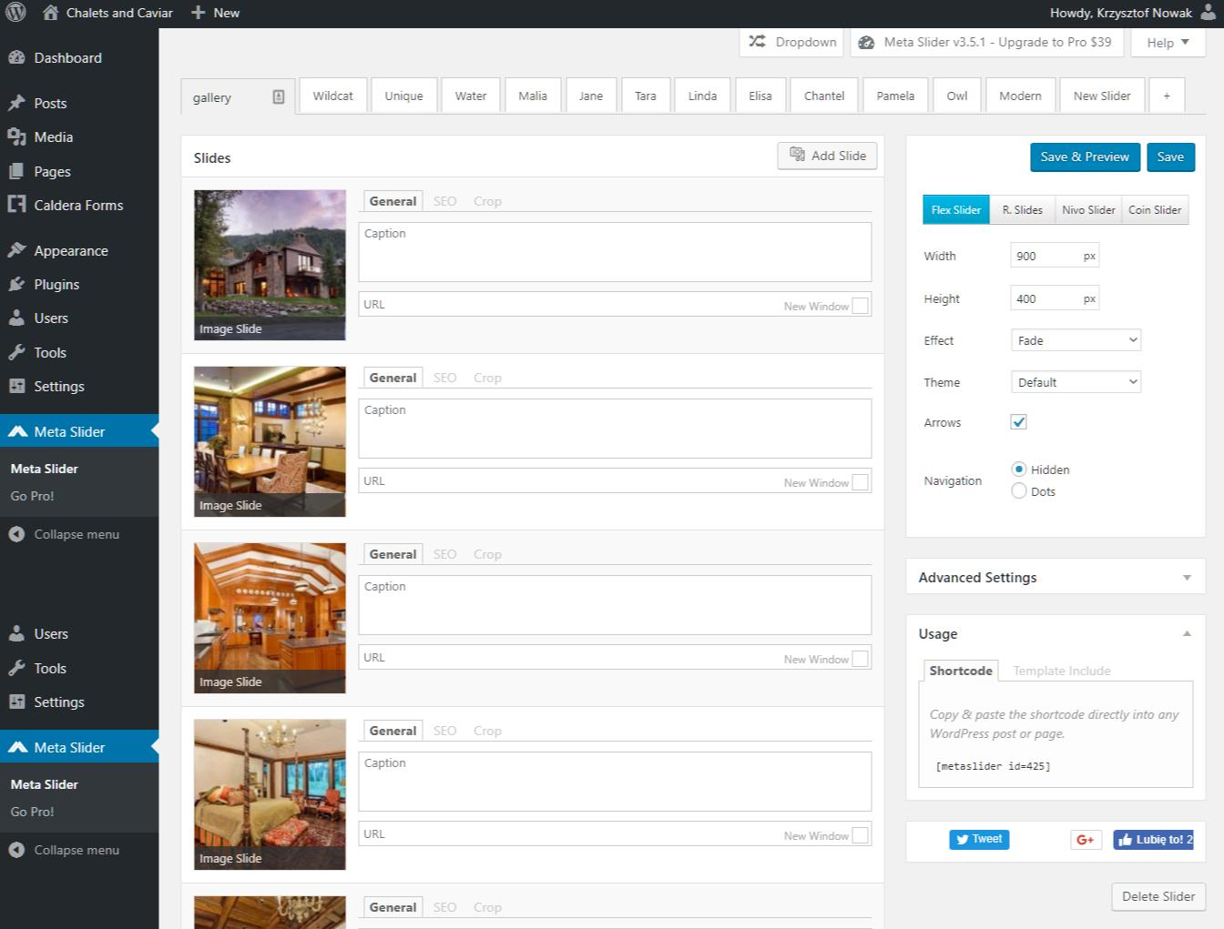

## Creating, editing and deleting an offer

Now it’s time to put everything together. Let’s assume that content of an offer is ready in form of spellchecked plain text.

1. Create new offer.
   1. Click on **“Posts > Add New”** item in menu on left side of administration panel.
2. Add offer **“Title”**.
   1. Type title in first input field on top.
3. Add offer content.
   1. Manually type in or paste offer content into editor area.
   2. You can use editor buttons to add some styling to the text.
4. Add gallery.
   1. After finishing editing content place cursor in the new line at the end of content and click editor button **“Add slider”**.
   2. Choose the gallery name corresponding to your offer.
5. Set type of the offer
   1. In the box titled **“Categories”** select **“chalets for sale”** or **“chalets for rent”**
6. Add feature image
   1. In box **“Featured Image”** click link **“Set featured image”**.
   2. In the media modal window select leading photo of an offer and approve selection.
   3. You can always change your choice by clicking the featured image thumbnail and choosing another photo from media library.
7. Add short offer summary that will be displayed on the list of offers.
   1. Go to the bottom of the page and fill the box titled **“Excerpt”**.
8. Save you offer.
   1. Click **“Publish”** button.
   2. When editing or modifying existing offer to save changes click **“Update”** button.
9. Preview changes.
   1. To see applied changes you can always click **“Preview”** button.
10. Edit an offer
    1. Click on **“Posts”** to display list of post.
    2. Move pointer over the offer to edit and click **“Edit”** link or just click on **title**.
11. Delete an offer
    1. Click on **“Posts”** to display list of post.
    2. Move pointer over the offer to remove and click **“Trash”** link.

**Remember to always save your work.**

**Creating an offer**

**1**

**2**

**3**

**4**

**5**

**6**

**7**

**8**

**9**

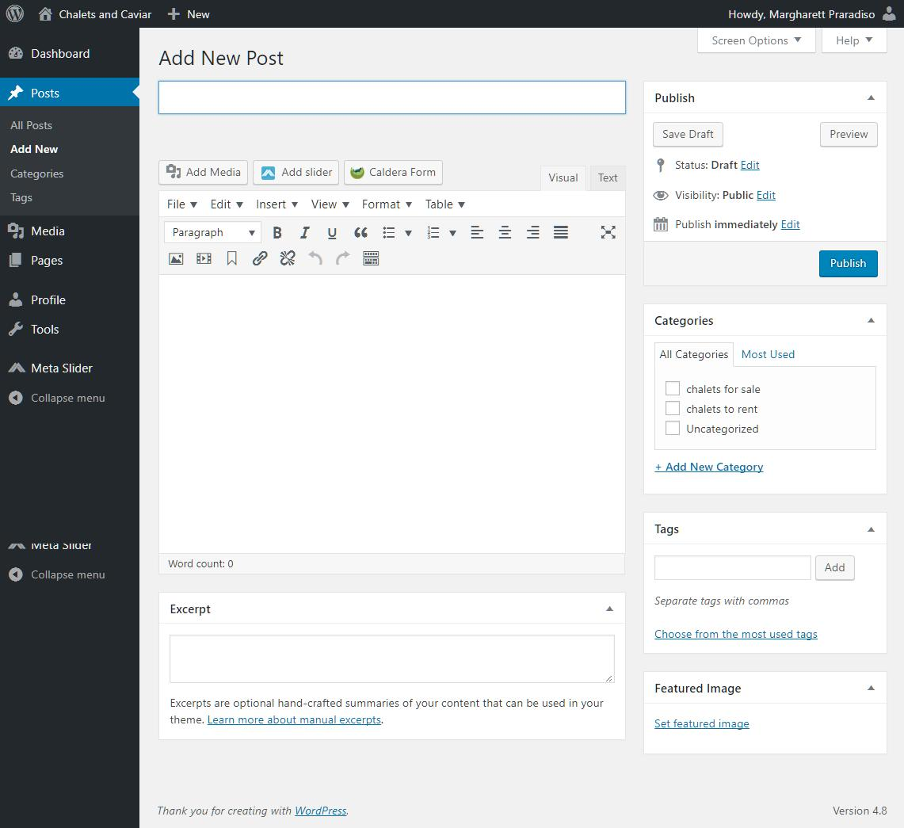

**Edit or delete an offer**

**10a,11a**

**10b, 11b**

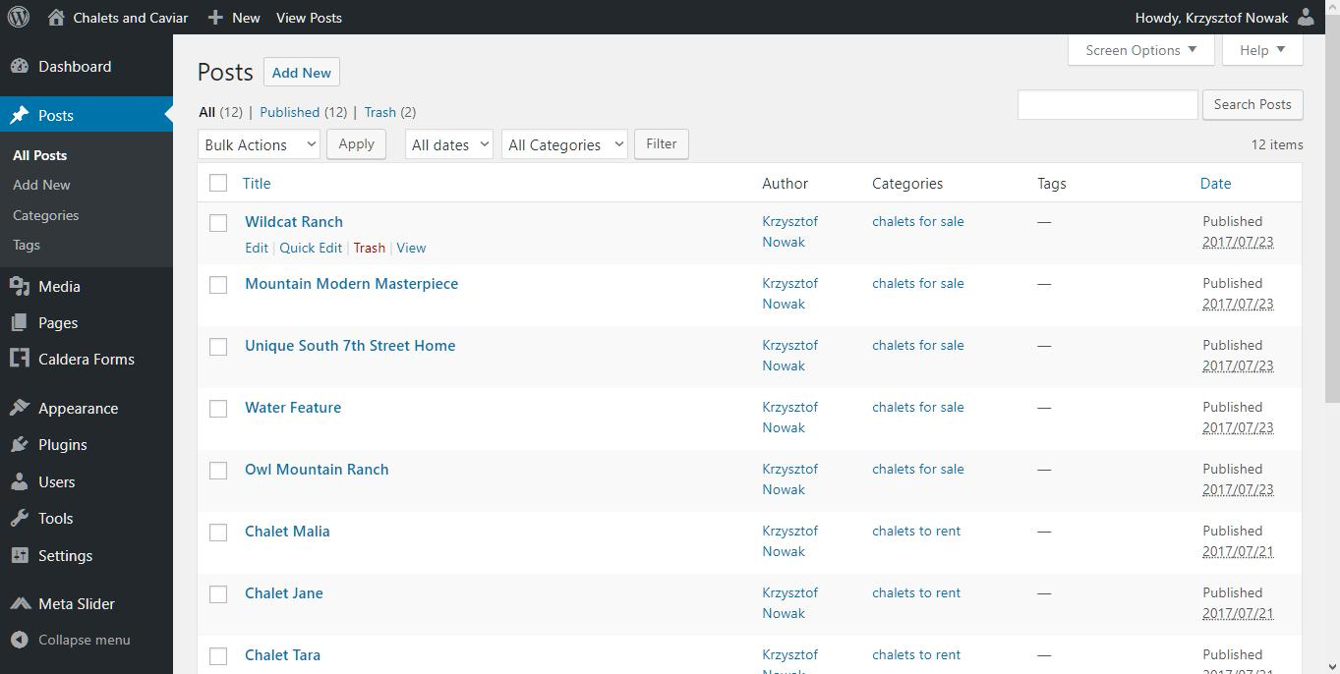

# Learning and sources

**For learning purposes** there are many online guides and courses that person maintaining webpage could use. There are few of them beneath. Use the one according to your own preferences.

* <https://codex.wordpress.org/First_Steps_With_WordPress> -   
  Open source documentation of Wordpress
* <https://youtu.be/f1zaynY93Iw>  
  How to creating-and-editing-pages in Wordpress tutorial - YouTube tutorial

**Image editing tools**

* <http://optimizilla.com/>  
  Image online compressor
* <http://www.picresize.com/>  
  Image online resize and crop tool

**Sources:**

* Wordpress - <https://wordpress.org/>,
* Sirius-Lite Theme - <https://www.lyrathemes.com/sirius/>